Some Syntax and Rules

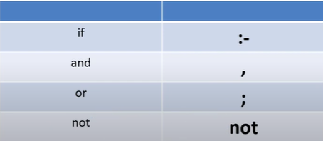

Variables only starts with Capital letters or an underscore

Facts

Loves(rose).

Color(black).

Likes(Ram, Shyam).

Rules

If then, and, or

Likes(X,Y) :-

Friends(X,Y)

<https://swish.swi-prolog.org/>

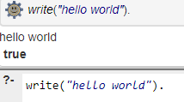

**Hello world**

?- write("hello world").

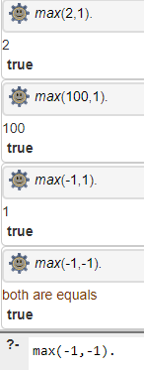**Max of two**

max(X,Y):-

(

X=Y ->

write('both are equals')

;

X>Y ->

(

Z is X,

write(Z)

)

;

(

Z is Y,

write(Z)

)

).

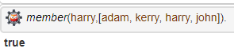**Recursive Call**

member(X, [X|_]).

member(X, [_|Y]):-member(X,Y).

?- member(harry,[adam, kerry, harry, john]).

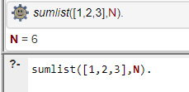**Sum**

sumlist([], 0).

sumlist([H|T], N) :- sumlist(T, Nl), N is Nl+H.

?- sumlist([1,2,3],N).

**%John likes anyone who likes cake**

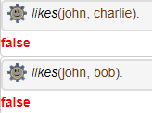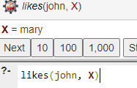likes(mary, cake).

likes(bob, fruit).

likes(Charlie, carrot).

likes(john, X) :- likes(X, cake).